
Company
Logotype

Cone Beam Computed Tomography- Report



Porur Dental X-rays & CBCT

Patient Name : Miss. Vaishnavi. A. R | Date of Report : 19.04.2024
Age/ Gender : 27 years/ Female | Region of Interest : CBCT Mandible
Referring doctor: Dr. K. Balaji | Indication : Impacted tooth
Clinical Notes: Nil
PATIENT INFORMATION

CBCT- Mandible provided
CBCT – IMAGE DETAILS

RADIOGRAPHIC INTERPRETATION

- The long axis of 38 and 48 appears to be parallel to the long axis of the adjacent teeth 37 and 47 respectively.
- The crown of 38 and 48 is present partially within the ascending ramus of mandible.
- The alveolar bone distal to 38 is present with mild area of hypodensity extending from adjacent to the crown upto to the radicular portion of 38.
- Distance between the apical portion of 38 and the Inferior Alveolar nerve canal: in contact.
- Distance between the apical portion of 48 and the Inferior Alveolar nerve canal: 1.81 mm.

RADIOGRAPHIC IMPRESSION

- Partially impacted: 38, 48.
- Pericoronitis: 38.

Kindly correlate with clinical findings


IMAGES FOR REFERENCE

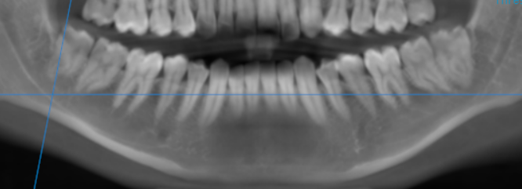

3-DIMENSIONAL VIEW

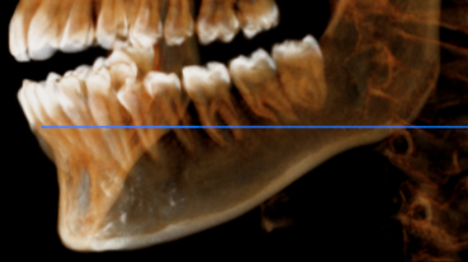

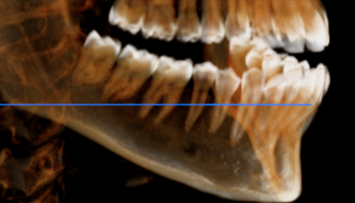

CROSS SECTIONAL VIEW

38 region- contact with the inferior alveolar nerve canal | 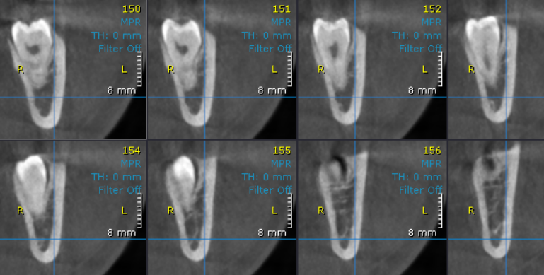
48 region- contact with the inferior alveolar nerve canal | 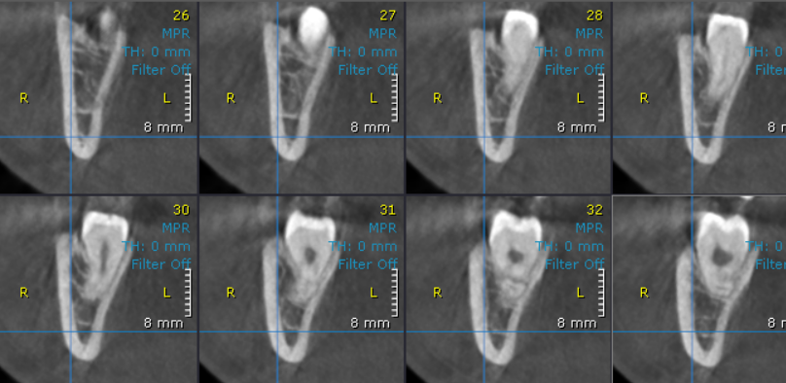

**** End of report ****

